*Jahangirnagar University*

*Computer networking Lab*

*Assignment*



Course Title: Computer Networking laboratory

Course Code: CSE-402

Submitted by:

Name: Md. Omar Faruque Abir

Roll: 44

Submitted Date : 30-08-2019

**Various Commands in computer networking:**

**tracert**: The tracert command is a Command prompt command that's used to show several details about the path that a Packet takes from the computer or device you're on to whatever destination you specify.

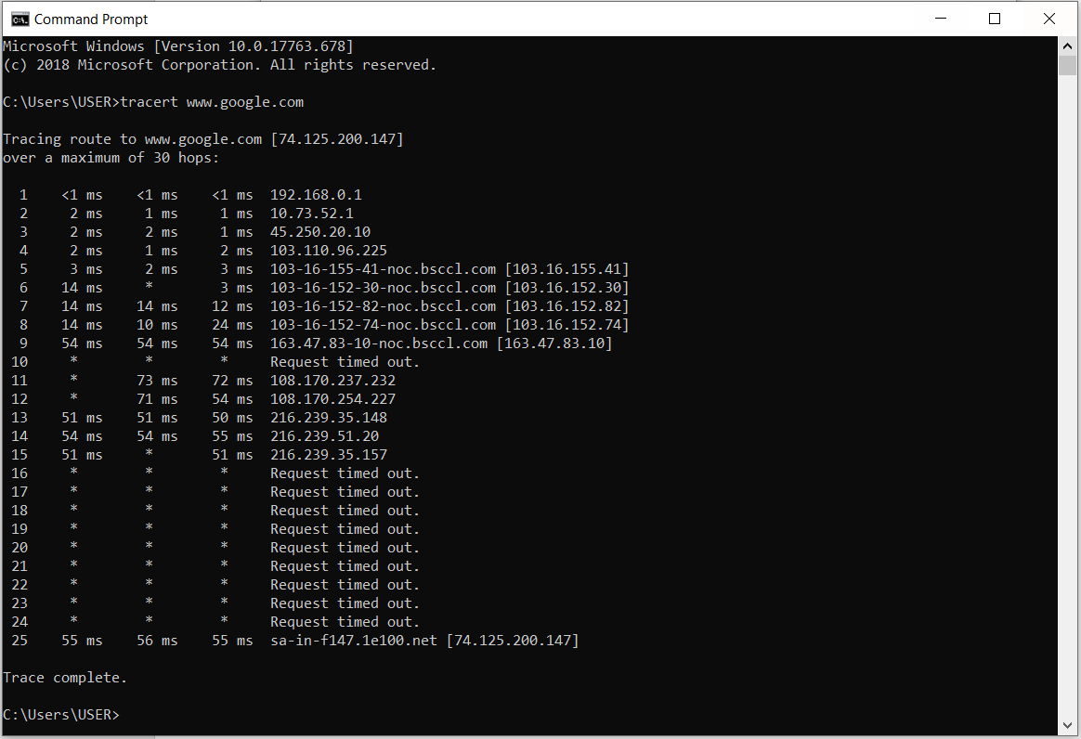

**Ipconfig:** In computing, ipconfig (internet protocol configuration) is a console application of some operating systems that displays all current TCP/IP network configuration values and refresh Dynamic Host Configuration Protocol (DHCP) and Domain Name System (DNS) settings. 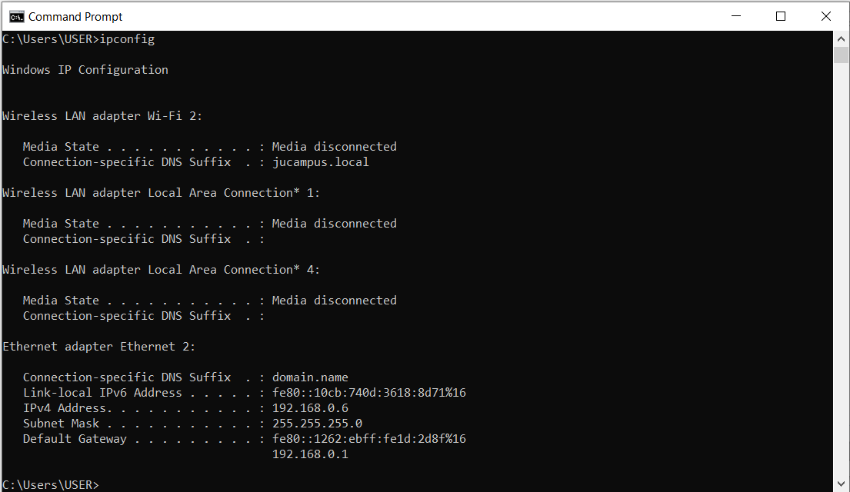

**Ping:** The ping command is a Command Prompt command used to test the ability of the source computer to reach a specified destination computer. The ping command is usually used as a simple way to verify that a computer can communicate over the network with another computer or network device. The ping command operates by sending Internet Control Message Protocol (ICMP) Echo Request messages to the destination computer and waiting for a response. How many of those responses are returned, and how long it takes for them to return, are the two major pieces of information that the ping command provides.

**Ping command syntax:**

**ping** [**-t**]

-t Using this option will ping the target until you force it to stop by using Ctrl-C.

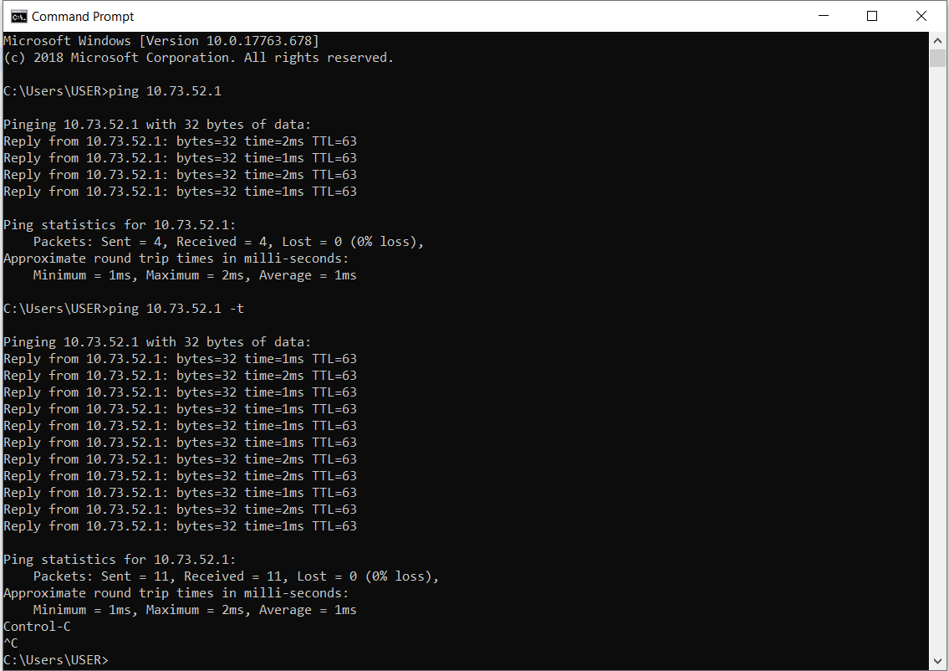

**Simulation of a packet transfer using Hub and switches:**

**Introduction:**

Hub: A hub is a component of a network with a high-degree node. Hubs have a significantly larger number of links in comparison with other nodes in the network. The number of links (degrees) for a hub in a scale-free network is much higher than for the biggest node in a random network, keeping the size N of the network and average degree <k> constant.

The existence of hubs is the biggest difference between random networks and scale-free networks. In random networks, the degree k is comparable for every node; it is therefore not possible for hubs to emerge. In scale-free networks, a few nodes (hubs) have a high degree k while the other nodes have a small number of links.

Switch: A switch is a device in a computer network that connects other devices together. Multiple data cables are plugged into a switch to enable communication between different networked devices. Switches manage the flow of data across a network by transmitting a received network packet only to the one or more devices for which the packet is intended. Each networked device connected to a switch can be identified by its network address, allowing the switch to direct the flow of traffic maximizing the security and efficiency of the network.

A switch is more intelligent than an Ethernet hub, which simply retransmits packets out of every port of the hub except the port on which the packet was received, unable to distinguish different recipients, and achieving an overall lower network efficiency.

**Description:**

We used cisco packet tracer for simulation. Several computer devices are connected through the hubs and switches and different ip addresses were assigned to them. Then a packet is sent through them to check the characteristics of hub and switches.

**Simulation:**

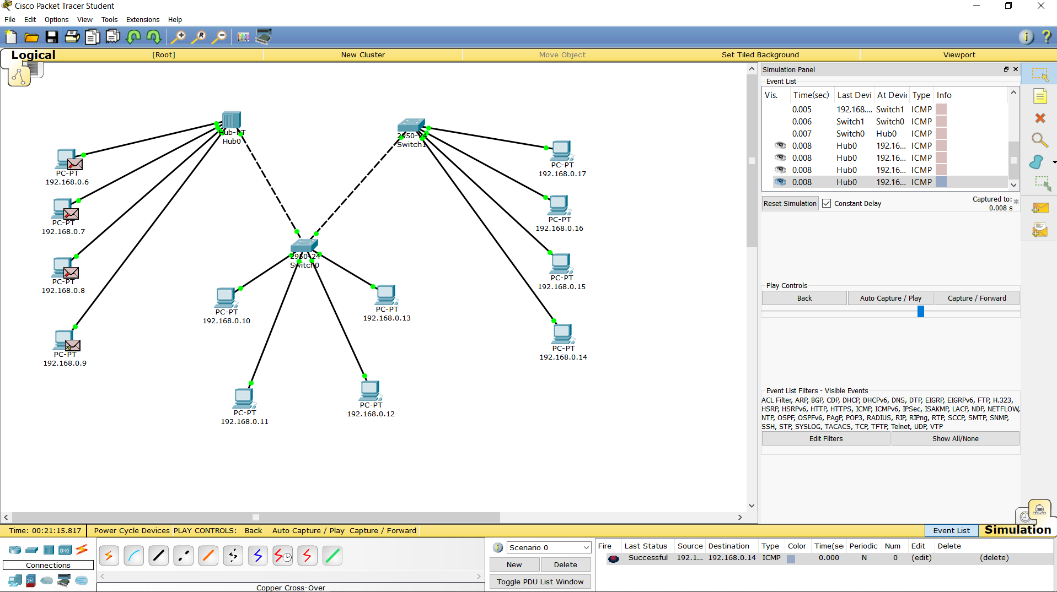

**Result:** We can see that the hub sends the packet to all the other nodes except the node the packet came from, on the other hand switches send packet to only to its destination node. switcher works smarter than hub.

**Comment:** Switches should be used whenever hardware cost is not of concern for data transfer.